Cheddar

“for people who love preserving capital and supporting gourmet producers”

Intro & Goal
Our goal is to make Cheddar the destination to invest in rare food and beverages, including cheese and wine. Others in this space focus on one type of beverage. Cheddar is both a place to preserve capital, but also raise capital for the slow-moving cheese industry without going to a bank (https://www.cnbc.com/2016/02/03/italian-cheese-firm-sells-parmesan-backed-bond.html).

Who’s it for?

- Epicureans - those who enjoy discovering and enjoying new sensual experiences
- Alternative Investors - always searching for new ways to preserve or grow capital. Options will be presented in an offering size palatable to accredited and non-accredited investors alike.
- Cheese/food producers - From mature producers to novice producers, Cheddar offers a way to both build a market and maintain capital while cheese ages
- Wine/Beverage producers - Same profile as the above, except for beverages the offerings would more likely come from established brands.

Why build it?

- Rare food/beverage returns are not correlated with the stock market. Investors are looking for a place to put capital to grow or preserve it.
- Opportunity to build and own a marketplace
- Opportunity to enable capital access for more amateur producers

What is it?

Glossary

- Offering - new investment opportunity
- Shelf - User’s collection of investments
- Chat - chat group for users to speak with each other

User Types

- Non-Registered Users - people that have no yet registered
- Registered Viewers - people that have registered and can invest
- Registered investments - registered users that can post an investment offering
- Admins

Offering View
Shows offerings which are open, closed, coming soon.

Personal View
Shows what a user is invested in

Email Notifications
Users receive the following email notifications:

- Weekly offerings digest - List of offerings open, closing soon, upcoming offers, including amounts and small blurb.

Registration
Every user must register and comply with SEC KYC-AML requirements including:

- Name
- SSN
- address
- Drivers license

Additionally, they must also provide:

- Email Address
- Fund source

Brainstormed Ideas

- Offer quarterly buy/sell days.
- Chat groups within the app
- Create a demand for products with podcast
- Plaid or stripe integration
- Have an opportunity for those with more capital to buy, hold food/beverage, then have it shipped to them whenever they want to indulge in it.

Competitors & Product Inspiration

- Otis - Art and collectible fractional ownership/investing
- Rally Road - Art, collectible, and beverage fractional ownership/investing
- Vinovest- wine investment

Seeding Users & Content
Initial contributors will be hand-picked to create exclusivity and reduce potential spam. Ideal contributors will be recognizable people or aggregators in the crypto or alternative invest (Pomp, Jason Calcanis, Altan Insights).

To capture higher profile investment personalities, we’ll need to research people who’ve show interest in similar investments before on their shows or social media.

Mockups

Intro screen
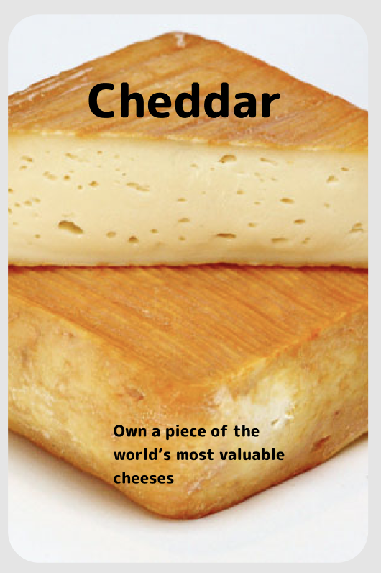

Offering View
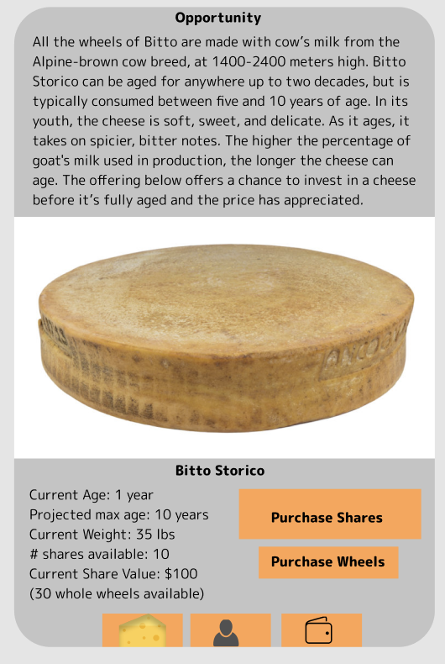

User ‘shelf’ (akin to a wallet)
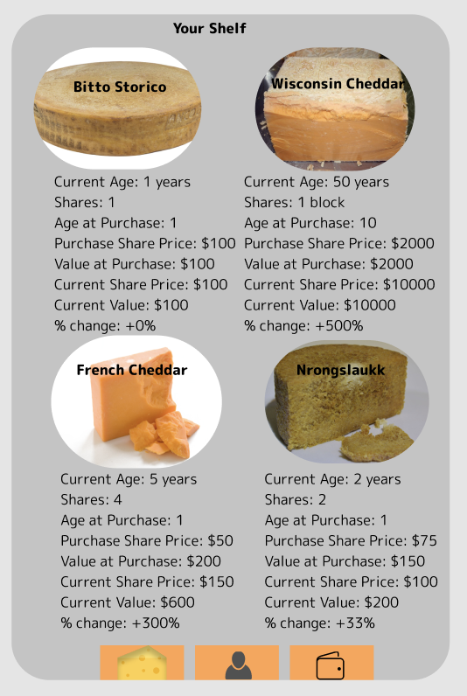

Go to Market

- Engage/Recruit Influencers - make them feel part of the product’s success and design
  - Ask for direct product feedback
  - Feedback on blog post/press release
- Invite Contributors Before Public Launch - ensure content is populated
- Blog Post - “Alternative Investments”
  - Post on Altan Insights?
  - Submit to TechCrunch, globe newswire, Kulture Lab, yahoo finance, the business of fashion, barron’s, forbe, business insider, culture magazine, the cheese connoisseur
- Press Release
  - Reach out to press contacts (see above)
  - Mass distro other press (see http://customerdevlabs.com/2013/09/24/google-news-api-mturk-press/)
- Product Hunt, the Hustle, Robinhood Snacks, Altan Insights

Post-Launch Marketing

- Product Deconstructions Blog Posts

